**CANTEEN MANAGEMENT SYSTEM**

PROJECT REPORT -2

Sai sasanka (U101115FCS136)

P saigiriraj (U101115FCS121)

Santosh Kumar Boyina (U101115FCS140)

Rahul Kumar B (U101115FCS264)

P Revanth (U101115FCS265)

**Individual Contribution:**

**Back end:**

**Santosh and Revanth:** Prepared the canteen management database which consists of:

Back end code and commands for connecting front end and backend [Queries]

**Tools used**: SQL Workbench

**Front end:**

**Sasanka:** Prepared the Login window, the registration window, the canteen management window, the billing window, the inventory window

**Tools used:** Eclipse neon with window builder plugin

**Languages used**: Java Swing(GUI) And the Jdbc framework of java

**Giriraj:** Prepared the employee details window

**Tools used:** NetBeans IDE

**Rahul:** Prepared the monthly bill generator

**Tools used:** NetBeans IDE

**Progress:**

The following screenshots give a glimpse of the Canteen Management system’s progress.

The windows in the screenshots do not contain any data as of now and are only the “skeleton” of the actual project.

The screenshot for the inventory window is not available as it’s still under progress.

The linking of the database to the application is under progress and driver used for the process is a JDBC thin driver.

The project should take only a few more days to complete.

Screenshots:

**Employee Details:**

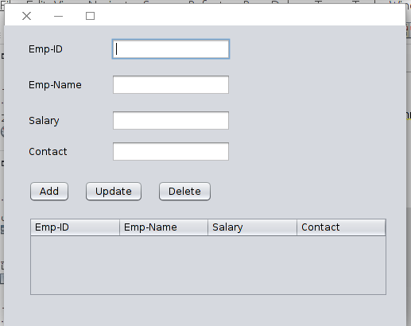

Registration form :

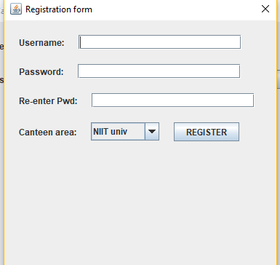

Home Page : 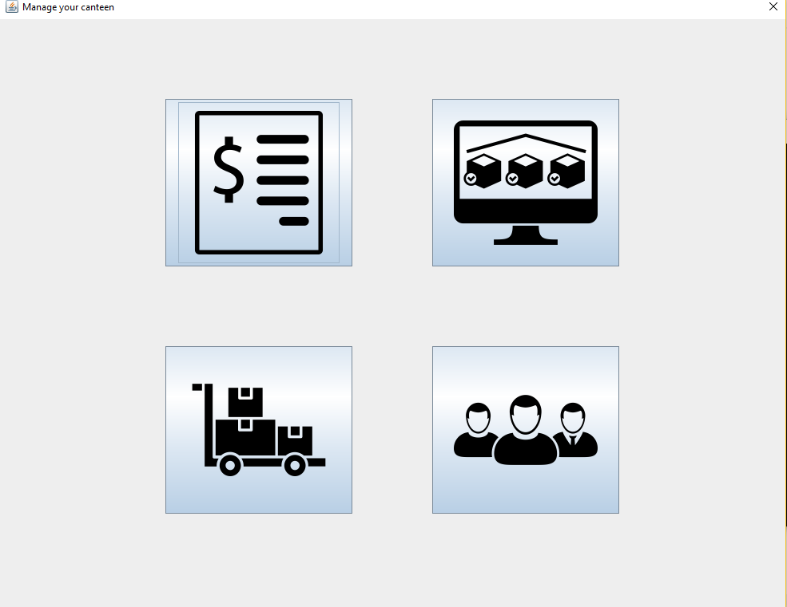

Login and Billing windows:

